
April, 2005 Issue # 5

Outgoing Chair’s Report

P. Ramond

Parting Thoughts

It has been a busy year. Much has been achieved; much more remains to be done. Through the hard work of many of our colleagues, the Faculty Senate has redefined the Tenure Process, the Grievance Procedures, and the Policy Councils are learning their trade. Faculty Compensation is recognized as a priority by the Board of Trustees and the Administration. The Faculty Senate is on a steep learning curve that is going to test Shared Faculty Governance.

A case in point is the formulation of the New Strategic Plan. Deans submitted their unit's aspiration after consulting with their faculty, as they should have, but there was no equivalent group of the most visionary faculty across the campus to identify new intellectual directions, and suggest interdisciplinary opportunities unique to our University.

As the Faculty Trustee, I addressed the crucial importance of graduate education and students, as all Faculty understand the need for first rate graduate students. While Science Faculty need well-equipped laboratories to succeed, Libraries are the lifeblood of the Humanities. The Faculty Senate has identified the neglect of our libraries as an obstacle to reaching the next level.

The University of Florida will not achieve Top Ten status without stellar programs both in the Humanities and in the Sciences.

Rome was not built in a day; and our efforts this year have added a step in the ladder that leads us to greatness!

It has been a rewarding experience to serve the Faculty. The University of Florida requires your involvement to attain its desired status. So keep stretching the limits of knowledge and the minds of your students, and stay connected.

Pierre Ramond

Inside you will find….
Chair-Elect Appointment | Page 2
March Faculty Senate Meeting Resolutions | Page 2
April Faculty Senate Meeting Items | Page 2
Doctoral Dissertation/Mentoring Advisor Awards | Page 3
Laudamus | Page 4-6
April Calendar of Events | Page 7

Incoming Chair’s Report
K. Tanzer

How can the Faculty Senate help the University of Florida improve? This is the question we discussed at a recent Senate Steering Committee meeting, as we began to prepare for next year’s efforts.

My predecessors—Pierre Ramond, Tony Brennan, Jean Larson, Richard Briggs, Joe Layon and Jim Pettigrew—have progressively improved the Faculty Senate’s effectiveness over the past five and a half years of elected leadership. Our Senate now satisfies virtually all the traits of effective Senates as outlined by the American Association of University Professors (look under Governance, Resources at www.aaup.org). We have reinstated elected faculty representation on existing University committees and created new, comprehensive Policy Councils charged with addressing all aspects of the University’s academic mission. A much larger group of faculty members from across the University now participate in shared governance, though still far too few.

Over the next year I will work with the Senate to strengthen our internal governance procedures and to continue to build a culture of commitment to shared governance across the University. This is necessary foundation, but it is not sufficient to improve the University of Florida.

To improve our University, the Faculty Senate must become increasingly proactive rather than reactive. We have begun by working with the administration to commission excellent reports and recommendations on Tenure and Promotion, Faculty Compensation, University Libraries and Sustainability, to name a few. But as we become more logistically capable, our Senate perspective must broaden. We must look ahead, to foresee and cultivate new academic opportunities, and around us, to incorporate our UF colleagues’ best practices. We must light more fires and put out fewer fires.

We have over 4,000 smart, hardworking, internationally networked faculty members at the University Florida. To improve, we need the synergy that university-wide faculty collaboration will generate.

Kim

Faculty Senate Chair-Elect
Appointment

Congratulations
Danaya Wright, Professor, Law
Professor Wright was elected as the 2005-2006 Faculty Senate Chair-Elect,
receiving 40 of the 78 votes cast.



March Faculty Senate
Meeting Resolutions
- Honorary Degree Committee Nominations
Barry Ache, Chair
Honorary Degrees, Distinguished Alumnus Awards & Memorials Committee
- Edward Villella, Founding Artistic & CFO of the Miami City Ballet
PASSED
- Dr. Nicholas Bodor, Chief Scientific Officer, IVAX Corporation
PASSED

April Faculty Senate
Meeting Items
Action Items
- Proposed Constitutional Language
Article II Section 5 – APA Assembly
Chris Snodgrass, Chair
Constitution Committee
PASSED
- UF Calendars
2005 Commencement Ceremonies
Sheila Dickison, Chair
Curriculum Committee
REJECTED
- Name Change
Graduate Engineering Research Center
Sheila Dickison, Chair
Curriculum Committee
PASSED
- New Degree Proposals
Ken Gerhardt
Graduate School
- Masters of Science with a Major in Animal Molecular & Cellular Biology
PASSED
- Doctor of Philosophy with a Major in Animal Molecular & Cellular Biology
PASSED
- Masters in International Taxation
PASSED

Information Items
- University Library Policy
Scott Nygren, Chair
Policy Council on Academic Infrastructure & Support

- Rules Report
Chris Snodgrass, Chair
Constitution Committee

Doctoral Dissertation Advisor/Mentoring Award Winners
Awards are given each year to advisors selected on a competitive basis. The winners receive a $3,000 award and an additional $1,000 to support their graduate studies.
2004-2005 Winners:
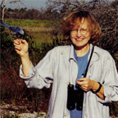
Dr. H. Jane Brockmann
Professor, Zoology
http://www.zoo.ufl.edu/Faculty/brockmann.html
Professor Brockmann is an animal behaviorist interested in the evolution of alternative strategies and tactics and the economics and mechanisms of decision making in animals. Currently involved in studying the evolution of mating and nesting behaviors of horseshoe crabs. Brockmann is also interested in sexual selection, mate choice, and paternal care, the evolution of sex ratios, the evolution of life-history patterns (e.g. emergence and diapause) and the evolution of social behavior (e.g. nesting behavior of solitary and social wasps).

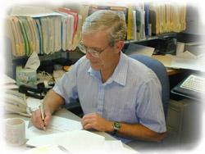
Dr. Paul Holloway
Professor, Materials Science & Engineering
http://holloway.mse.ufl.edu/index.htm
Professor Holloway is Director of MICROFABRITECH, an interdisciplinary materials research program at the University of Florida. Holloway is internationally recognized for his work in quantitative surface analysis; grain boundary and thin film diffusion, oxidation, and adhesion in microelectronic devices; thin film processing for microelectromechanical (MEMS) systems; contacts to semiconductors; surface passivation of compound semiconductors; basic science of wide-gap materials for light emitting diodes and lasers; and advanced phosphors for display technologies.

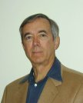
Dr. James Jones
Distinguished Professor, Agricultural and Biological Engineering
http://www.agen.ufl.edu/newsite/mainpages/Faculty_pages/PDF%20Profiles%20rev/Jones_Jim.pdf
Dr. Jones specializes in mathematical modeling of plant growth and environmental interactions (with soil and atmosphere), in analysis of agricultural systems for research and decision support applications, and in computer control of plant growth systems, including greenhouses and research growth systems.

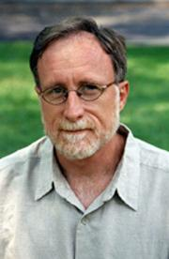
Dr. Greg Neimeyer
Professor, Psychology
http://www.psych.ufl.edu/~neimeyer/gnhome.html
Dr. Neimeyer is the graduate school coordinator for UF’s psychology program. He is in charge of overseeing the university's doctoral programs in cognitive psychology, sensory processes, clinical and developmental psychology, behavior analysis, psychobiology and social psychology. Dr. Neimeyer’s current research interests include social influence in a clinical context, relationship development and disorder, and multi-cultural counseling.

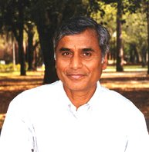
Dr. Ramesh Reddy
Professor, Soil & Water Science
http://wetlands.ifas.ufl.edu/reddy.htm
For the past 15 years, Dr. Reddy has led a team of UF researchers, working in cooperation with the state agencies (Water Management Districts) and federal agencies (USDA), who have been investigating water quality related issues in three major freshwater ecosystems of south Florida. Key research issues addressed include:(i) nutrient loading impact on wetlands and streams in the Lake Okeechobee Basin;(ii) internal nutrient cycling and loading in Lake Apopka and Lake Okeechobee; (iii) historical nutrient loading impacts in the Everglades; and (iv) long-term nutrient retention capacity of constructed and natural wetlands.

College of Liberal Arts and Sciences
Faculty Awards and Honors

HUMANITIES

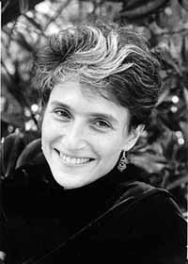
Associate professor of history Sheryl Kroen has received a Frederick Burkhardt Residential Fellowship for Recently Tenured Scholars by the American Council of Learned Societies, funded by the Rockefeller Foundation and the Andrew W. Mellon Foundation. The $75,000 award will allow Kroen to work on her proposed research project, “Capitalism and Democracy: The Lessons of the Marshall Plan,” during the 2006-2007 academic year in residence at the National Humanities Center in Research Triangle Park, NC. She also received a $30,000 fellowship from the German Marshall Fund to work on the same project in Paris next year.

Assistant professor of religion Leah Hochman was invited to join the Oxford Centre for Hebrew and Jewish Studies at Oxford University for the spring semester in 2005. Every year, the Skirball Fellows Program invites seven scholars from around the world to stay at the Yarnton Manor estate, where the Centre is located, to pursue research projects in all areas of Jewish history, literature, languages and thought.

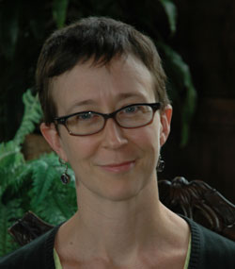
The National Endowment for the Humanities has awarded assistant professor of women’s studies Trysh Travis a 12-month fellowship. Travis will use the $40,000 award to complete her book, The Persistence of Sentiment: Contemporary American Literature and the Culture of 12-Step Recovery.
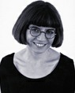
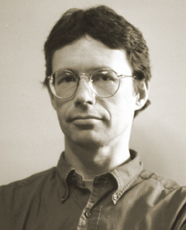
English professors Debora Greger and William Logan have been honored by Centenary College in Shreveport, Louisiana with the Corrington Award for Literary Excellence. As the 15th and 16th recipients of the award, named in memory of Centenary alumnus John William Corrington, the two received bronze medals. The award also carries a special feature—a book by each winner is incorporated into all sections of the fall first-year experience courses at Centenary.

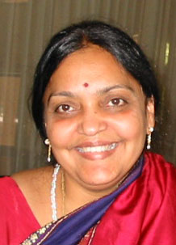
Religion professor Vasudha Narayanan received an American Council of Learned Societies fellowship for 2004-2005. The funding supports her research on "Churning the Ocean of Story: Retelling Narratives of Hinduism in Cambodia and India."
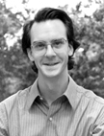
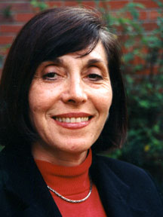
The American Council of Learned Societies awarded associate professor of philosophy John Palmer a Frederick Burkhardt Residential Fellowship for Recently Tenured Scholars. The fellowship carries a $65,000 stipend, which Palmer is using during the 2004-2005 academic year to develop a new narrative for the history of early Greek philosophy.

Associate professor of linguistics Diana Boxer was a Rockefeller Foundation Fellow during July and August 2004 at the Bellagio Study Center in Bellagio, Italy.

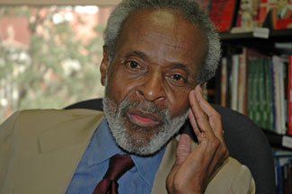
Professor of English Ron Carpenter received the 2004 Douglas Ehninger Distinguished Rhetorical Scholar Award, which recognizes Carpenter’s multiple publications and presentations around a rhetorical topic or theme that have demonstrated intellectual creativity, perseverance and impact on academic communities.

English professor James Haskins received the 2004 John and Patricia Beatty Award from the California Library Association for his book Cecil Poole: A Life in the Law.

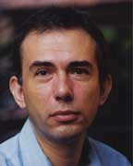
Assistant religion professor Mario Poceski received a Center for East Asian Studies Fellowship in Chinese Studies at Stanford University for the 2004-2005 academic year. He is working on a book that explores the attitudes toward morality and monasticism within the Chan school of late medieval Chinese Buddhism.

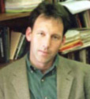
Associate professor of Russian studies Michael Gorman received the 2004 Best Book in Literature and Culture Award from the American Association of Teachers of Slavic and East European Languages for his book Speaking in Soviet Tongues: Language Culture and the Politics of Voice in Revolutionary Russia.

SOCIAL AND BEHAVIORAL SCIENCES

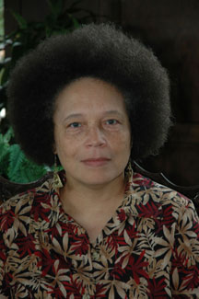
Faye Harrison, a professor of African-American studies and anthropology, has received the 2004 Society for the Anthropology of North America (SANA) Prize for Distinguished Achievement in the Critical Study of North America. The award is given annually in honor of a senior-level anthropologist who has made broad-based contributions to the field.

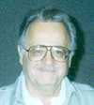
The National Council on Family Relations (NCFR) acknowledged professor emeritus of sociology Felix Berardo’s many years of leadership in the field of family studies by creating the Felix M. Berardo Award for Mentoring in his honor. The award will recognize faculty members in family studies for extraordinary efforts to provide students and colleagues with the guidance and social support essential to their career development and advancement.

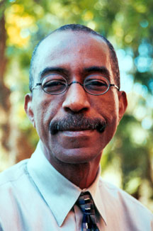
US Secretary of Health and Human Services Tommy Thompson has appointed sociology professor Terry Mills to the National Advisory Council on Aging. His appointment continues until 2008. As one of 18 members on the council, Mills will advise the secretary and the directors of the National Institutes of Health and the National Institute on Aging on matters relating to the conduct and support of biomedical, social, and behavioral research, training, health information dissemination, and other programs with respect to the aging process.
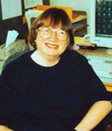
Professor emeritus of political science Peggy Conway received the 2004 Frank J. Goodnow Distinguished Service Award from the American Political Science Association in honor of her outstanding service to the community.
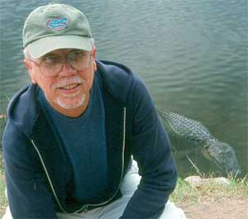
David Grove, a courtesy professor in the Department of Anthropology, was recently named a fellow of the American Academy of Arts and Sciences.
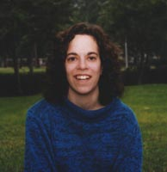
Assistant professor of psychology Lise Abrams was selected as one of the three recipients of the 2004 Women in Cognitive Science Mentorship Award from Women in Cognitive Science, an affiliate of the Psychonomic Society.

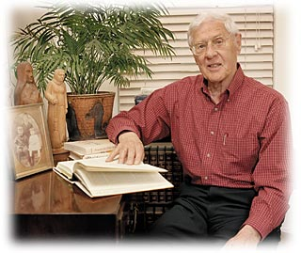
The Southern Gerontological Society has created the Gordon Streib Academic Gerontologist Award in honor of sociology professor Gordon Streib's scientific career and contributions to the field. The award recognizes outstanding career contributions to the advancement of gerontology through excellence in research that has contributed to the quality of life of older people, teaching of students and professionals and service to professional organizations.

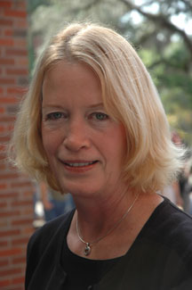
Communication sciences and disorders professor Patricia Kricos, who is also director of the Center for Gerontological Studies, was elected to serve a three-year term on the Board of Directors of the American Board of Audiology.

NATURAL AND MATHEMATICAL SCIENCES
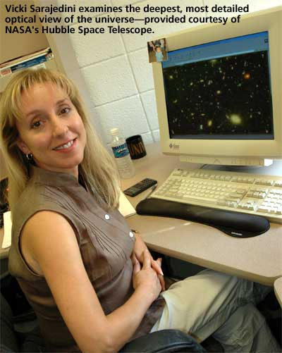
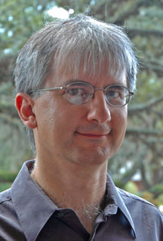
Assistant astronomy professor Vicki Sarajedini and assistant physics professor Stephen Hagen each received a 2004 National Science Foundation CAREER award. Only the top 10 percent of young tenure-track faculty in the US are given CAREER grants to support their research.

The Department of Energy Division of High Energy Physics selected assistant physics professor Konstantin Matchev to receive a 2004 Outstanding Junior Investigator (OJI) award.
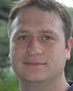
Assistant chemistry professor Adam Veige has received a $50,000 New Faculty Award from the Camille and Henry Dreyfus Foundation. He is one of nine professors nationwide to receive the honor. Veige was chosen based on his proposed research program, which aims to exploit structural, electronic and reactivity tenets to design reactive early transition metal complexes for the purpose of small molecule activation and catalysis
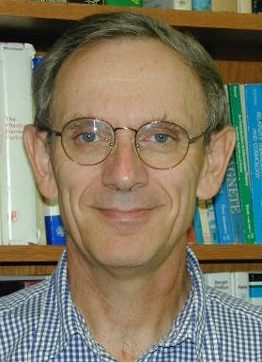
Physics professor Pierre Ramond was named the 2004 Oskar Klein lecturer by the Royal Swedish Academy of Sciences. As part of the honor, Ramond delivered a lecture at Stockholm University.

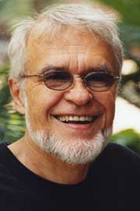
Chemistry professor James D. Winefordner was recently named a fellow of the Society of Applied Spectroscopy, and is one of the first to receive this honor. He has also received the Strock Award from the Federation of Analytical Chemistry and Spectroscopy Societies, given by the New England Section of the Society of Applied Spectroscopy in recognition of a selected publication of substantive research. Winefordner also received the Maurice Hasler Award at the Pittsburgh Conference, an annual conference on analytical chemistry and spectroscopy.

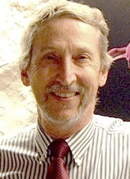
Professor emeritus of physics Dwight Adams has received the 2005 Keithley Award from the American Physical Society. Adams was recognized for his development of the capacitive pressure transducer, and for its application to the helium melting pressure thermometry and other scientific uses. He will receive $5,000 and a certificate citing his contributions.

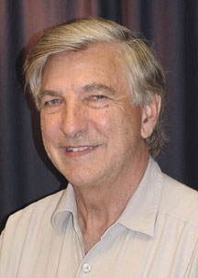
Chemistry professor Alan Katritzky was honored at the International Chemistry-Biology Interface Conference in Delhi, India when one of the symposiums, “Synthetic Strategies in Heterocyclic Chemistry,” was presented as a tribute. He also received the lifetime achievement award from the Indian Chemical Society and a plaque commemorating his election as the Foreign Fellow of the Indian National Science Academy by K.R. Narayanan, the former President of India.
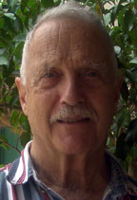
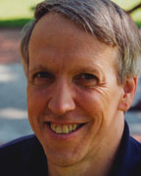
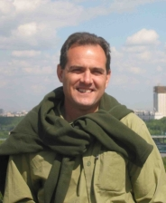
Three UF scientists have been named fellows of the American Physical Society. Physics professors Paul Avery and Peter Hirschfeld and chemistry professor Frank Harris each were elected for their original research and innovative contributions in applying physics to science and technology. No more than one-half of one percent of the society’s total membership is selected for fellowship status each year.

APRIL 2005
Calendar of Events
Sun | Mon | Tue | Wed | Thur | Fri | Sat
 |  |  |  |  | 1 | 2
  3  Daylight Savings Time Begins | 4 | 5 | 6  12:30-2:30pm  Constitution Committee  354 Tigert Hall | 7  3:30-5:00pm  Council on Planning, Budgeting & Resource Allocation  354 Tigert Hall | 8 | 9
10 | 11  9:30 – 10:30am  Lakes, Vegetation & Landscaping Committee  232 Stadium | 12 | 13  3:00 – 4:30pm  Ad Hoc Compensation Committee  354 Tigert Hall | 14  3:00-5:00pm  Faculty Senate Meeting  Constans Theatre | 15 | 16
17 | 18 | 19 | 20 | 21  12:00 – 2:00pm  Senate Steering Committee Meeting  226 Tigert Hall | 22  1:00 – 2:30pm  Council on Infrastructure & Support  226 Tigert Hall  2:00-4:00pm  Nominating Committee  354 Tigert Hall | 23    Passover
24  Passover | 25 | 26 | 27  Administrative Professionals Day | 28 | 29  COMMITTEE  ELECTIONS END! | 30

Please contact us if you have any comments, questions, or suggestions.

We welcome your feedback!

faculty.senate@ufl.edu

