
March, 2005 Issue # 4

Chair’s Report

P. Ramond
Fellow Senators,
I continue to appreciate just how good a University we are as I see more of my colleagues get involved in the Faculty Senate. Their increased participation is bound to impact positively on the soon to be held Senate elections. The effectiveness of the Faculty Senate depends on the quality of those dedicated to Shared Governance.

A court sub-panel has ruled (2-1) that the collective bargaining units at UWF and FSU under the Board of Regents are still in place. These two universities have asked for an opinion from the whole court, ("en banc", as they say). Their ruling will affect UF as well. Hopefully we will know more by next month's Newsletter. In any event, this underscores the importance of the Faculty Senate as an independent body, representative of the Faculty, not of Union, nor Administration. As Nobel Laureate I. Rabi described the Faculty to then Columbia University President Dwight D. Eisenhower, "Sir, We are the University".

The search for a Provost, Part Deux, is proceeding and Faculty are encouraged to nominate their favorites to the Committee and to the Search Firm. For details, follow the link on the Faculty Senate webpage.

Finally, March Madness in Tallahassee:
The Governor's Higher Education budget contains no raise for Faculty. We look forward to a repeat of last year's Faculty raise package. Any less would be a serious setback for shared governance and UF's credibility as a top ten contender. Where will the funds come from? Good Luck President Machen!

And now for something completely different! There is a bill (#837) in the Florida Legislature that is trying to legislate what we can and cannot teach in the Classroom. A revealing excerpt: "Students have a right to expect that their academic freedom and the quality of their education will not be infringed upon by instructors who persistently introduce controversial matter into the classroom or coursework that has no relation to the subject of study and serves no legitimate pedagogical purpose.” You can read the whole bill at http://studentsforacademicfreedom.org/actions(boxattop)/Floridapage/Floridahousebill837.htm

Pierre

Policy Councils

Policy Council on Academic Freedom, Faculty Quality & Faculty Welfare
Mike Katovich, Chair

Policy Council on Academic Infrastructure & Support
Scott Nygren, Chair
The Policy Council on Academic Infrastructure & Support has two more meetings scheduled this year, both at 1:00-2:30pm on Fridays. On March 25th, Faith Meakin will make a presentation on the Health Science Center Library, and on April 22nd the Council will evaluate the year’s survey of support areas for future planning and recommendations.
Thanks,
Scott

Policy Council on Academic Planning, Budgeting & Resource Allocation
Frank Bova, Chair

Policy Council on Academic Policy, Curriculum & Structure
Jack Mecholsky, Chair

Policy Council on Academic Research & Scholarship
Saeed Khan, Chair

Inside you will find….
February Faculty Senate Meeting Resolutions | Page 2-3
Important Topics | Page 4
March Senate Meeting Agenda Items | Page 5
Faculty Senate Election Procedures | Page 5
Laudamus | Page 6
March Calendar of Events | Page 7
February Faculty Senate
Meeting Resolutions

- Constitutional Changes
Tim Taylor, Chair
Academic Freedom, Tenure, Professional Standards & Relations Committee
- The number of faculty required for a full AFTPRS panel hearing should be reduced from the current number of five (5) to three (3).

PASSED
- Upon the request of the Petitioner or Committee the University shall supply the Petitioner and Committee all relevant information pertinent to the petition

PASSED
- No faculty member shall have tenure removed, be dismissed, or suspended without pay and benefits until the University administrative process has been exhausted.

PASSED
- Within 25 days of receipt of both the record and report, or as soon thereafter as possible, the President shall: 1) adopt the conclusions of law and recommendations in the panel’s report and implement as deemed appropriate; or 2) modify the conclusions of law and recommendations in the Hearing Panel’s report and implement as deemed appropriate; or 3) reject the report in its entirety. In taking action the President may not rely on ex-parte communications and may not reject or modify findings of fact if they are supported by competent substantial evidence in the record. If the report is modified or rejected, the president shall furnish the parties specific reasons therefore. The decision by the President will be provided in writing to the parties. The President will meet with the Hearing Panel to discuss the decision.

PASSED

- New Degree
College of Engineering – Bachelor’s in Computer Science
Sheila Dickison, Chair
University Curriculum Committee

PASSED

Meeting Resolutions

(continued)

- New Department

College of Medicine – Department of Urology

Sheila Dickison, Chair

University Curriculum Committee

PASSED

- Proposed Constitutional Language

Chris Snodgrass, Chair

University Constitution Committee
- Academic & Professional Assembly
Proposed Amendment to Article II, Section 5
The Academic and Professional Assembly (APA) shall be the organizational representative of TEAMS A and Academic Personnel not represented in the Faculty Senate. The APA shall have the authority to approve its own bylaws, to appoint committees and other groups as are deemed necessary to aid in the performance of its mission, and to serve in an advisory capacity to the President and the Faculty Senate.

*TABLED*
- Determination of Assistant In for Faculty Membership
Article III
The faculty of the University of Florida are those
persons employed appointed full-time by the University of Florida during the regular academic year whose primary assignment is to carry out the
academic mission of the University, namely, teaching, research and academic service. Titles of these persons shall be set forth in the Senate
Bylaws, except that a person with one of the listed titles whose primary assignment is in a support capacity (for example, financial officer or
supervisor of computer services) shall not be considered a member of the faculty. Questions about the faculty status of an individual shall be
resolved by a committee charged with evaluating academic qualifications in the college in which the individual is appointed. The committee shall
determine status based on whether the primary assignment is the carrying out of the academic mission of the University.

PASSED
- Proposed Constitutional Language (cont.)
- Determination of Full-Time
(A) Titles
Persons who hold full-time employed by the University of Florida appointments during the regular academic year are members of the faculty
if they hold one of the following academic titles:
- Eminent Scholar
- Graduate Research Professor
- Distinguished Service Professor, Distinguished Research Curator
- Distinguished Professor
- Professor, Associate Professor, or Assistant Professor
- Curator, Associate Curator, or Assistant Curator
- Research Scientist, Associate Research Scientist, or Assistant Research Scientist
- Scholar, Associate Scholar, or Assistant Scholar
- Engineer, Associate Engineer, or Assistant Engineer
- Extension Scientist, Associate Extension Scientist, or Assistant Extension Scientist
- University Librarian, Associate University Librarian, or Assistant University Librarian
- Master Lecturer, Senior Lecturer, or Lecturer
- PKY University Developmental Research School Professor, PKY Associate Professor, PKY Assistant Professor, or PKY Instructor
- County Extension Agent IV, County Extension Agent III, County Extension Agent II, County Extension Agent I
- Any of the above titles modified only by clinical, research, or extension.

Full-time appointees University employees who hold one of the following the academic titles of Senior Associate In, Associate In, or Assistant In, are considered members of the faculty unless the appointing College certifies their primary assignment to be in administrative support areas of the University instead of in direct pursuit of the teaching, research and academic service missions of the University.
By December 15 of each academic year, each College shall transmit to the Secretary of the Senate a list of those Senior Associates In, Associates In, or Assistants In whose duties are primarily administrative support and who should be excluded pursuant to this section. A committee in each College, as required in Article III of the Constitution of the University of Florida, shall determine who is excluded on the basis of the principle stated in By-Law 21(B).
- Proposed Constitutional Language (cont.)
Any dispute as to exclusion under this section shall be referred to the College Tenure and Promotion Committee for final determination.
Senior Associate In, Associate In, Assistant In.
Appointees Employees satisfying the criteria in (1) and (2) above are members of the faculty if their and whose academic titles carry any of the
following a modifiers are members of the faculty if at only if the modifier is one of the following:
- Clinical
- Research
- Extension
(B) Faculty Characteristics
1. The following principle shall be considered in amending the criteria and titles listed above and in resolving ambiguous cases.
2. Members of the faculty share most of the following characteristics.
- They are hired through nationally competitive processes.
- They are retained and promoted using national, peer-reviewed criteria.
- They participate, to some degree, in teaching, research, and service.
- They are eligible for tenure.
- Their primary employer is the University of Florida.
- They hold a terminal degree in their field.
- They are hired by their faculty peers.
PASSED

Happy St. Patrick’s Day!
Suicide Prevention Day
Governor Bush proclaims March 23, 2004 as "Florida Suicide Prevention Day, A Day to Focus on Suicide Prevention Awareness.

The Chair of the Alachua County Board of County has proclaimed March 30, 2005 as Suicide Prevention Day

In the County of Alachua and invite all our citizens to join me in becoming aware, discussing and working to prevent depression and suicide.

March 17, 2005 Agenda Items
Information Items:
- Honorary Degree Nominations
Barry Ache, Chair
Honorary Degrees, Distinguished Alumnus & Memorials Committee

- Proposed Constitutional Language for Compensation Committee
Chris Snodgrass, Chair
University Constitution Committee

- University of Florida Calendars
Sheila Dickison, Chair
University Curriculum Committee

- Degree Proposal – Masters in International Taxation
Ken Gerhardt, Chair
Graduate Council

- Degree Proposal - Master of Science with a Major in Animal Molecular & Cellular Biology
Ken Gerhardt, Chair
Graduate Council

- Degree Proposal - Doctor of Philosophy with a Major in Animal Molecular & Cellular Biology
Ken Gerhardt, Chair
Graduate Council

- Faculty Athletic Representative
Albert Matheny, Chair
Intercollegiate Athletic Committee

Academy of Distinguished Teaching Scholars

Laurence Alexander
Department of Journalism
College of Journalism & Communications
lalexander@jou.ufl.edu

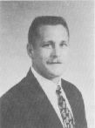
Robert Cox
Rinker School of Building Construction
College of Design, Construction & Planning
robcox@ufl.edu

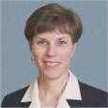
Gail Kauwell
Department of Food Science & Human Nutrition
College of Agriculture & Life Sciences
GPKauwell@mail.ifas.ufl.edu

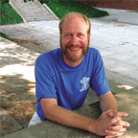
Doug Levey
Department of Zoology
College of Liberal Arts & Sciences
dlevey@zoo.ufl.edu

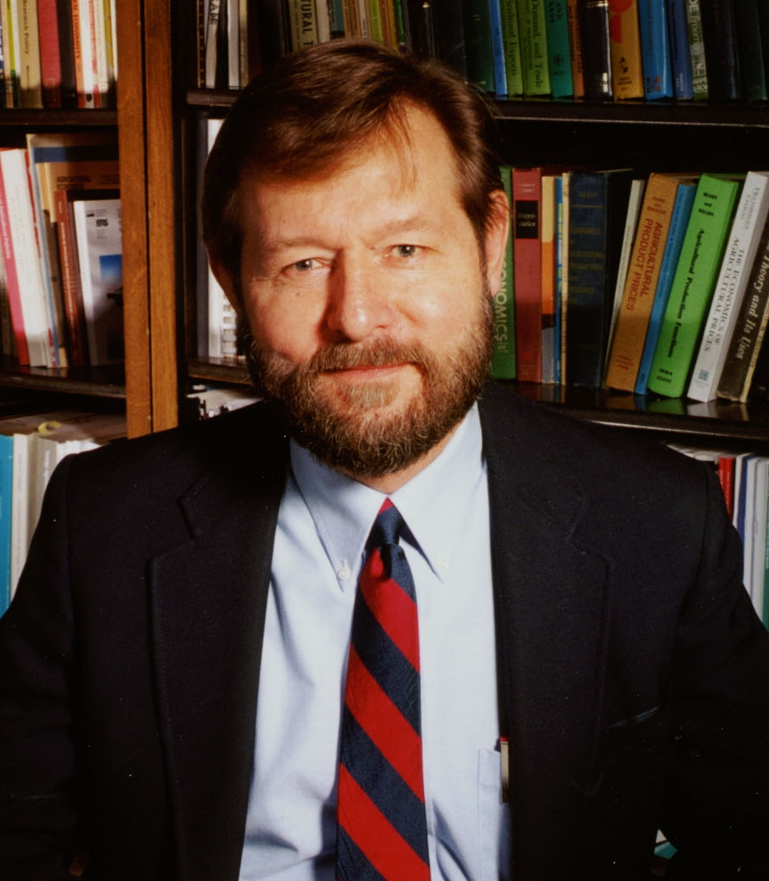
Michael Olexa
Department of Food & Resource Economics
College of Agriculture & Life Science
olexa@ifas.ufl.edu

Robert Ray
Department of English
College of Liberal Arts & Sciences
rbr@english.ufl.edu

These outstanding educators have demonstrated sustained innovation and commitment to teaching throughout their careers. They also have articulated their vision for promoting excellence across campus to the faculty committee that reviewed nominees to the Academy.

College of Medicine
Congratulations to the following faculty and staff in the University of Florida’s College of Medicine who have been recognized for professional achievements in teaching, research and education programs.

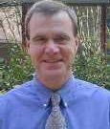
Terence R. Flotte, M.D.
Nemours Eminent Scholar Professor and Chair of Pediatrics

The Society for Pediatric Research has named Flotte as a 2005 recipient of the E. Mead Johnson Award for Research in Pediatrics, one of the most prestigious awards in the field of Pediatrics presented to two researchers each year. Recipients receive a $10,000 honorarium, at the Pediatric Academic Societies’ annual meeting in Washington, DC in May. Dr. Flotte is best known for his pioneering work on gene therapies for cystic fibrosis.

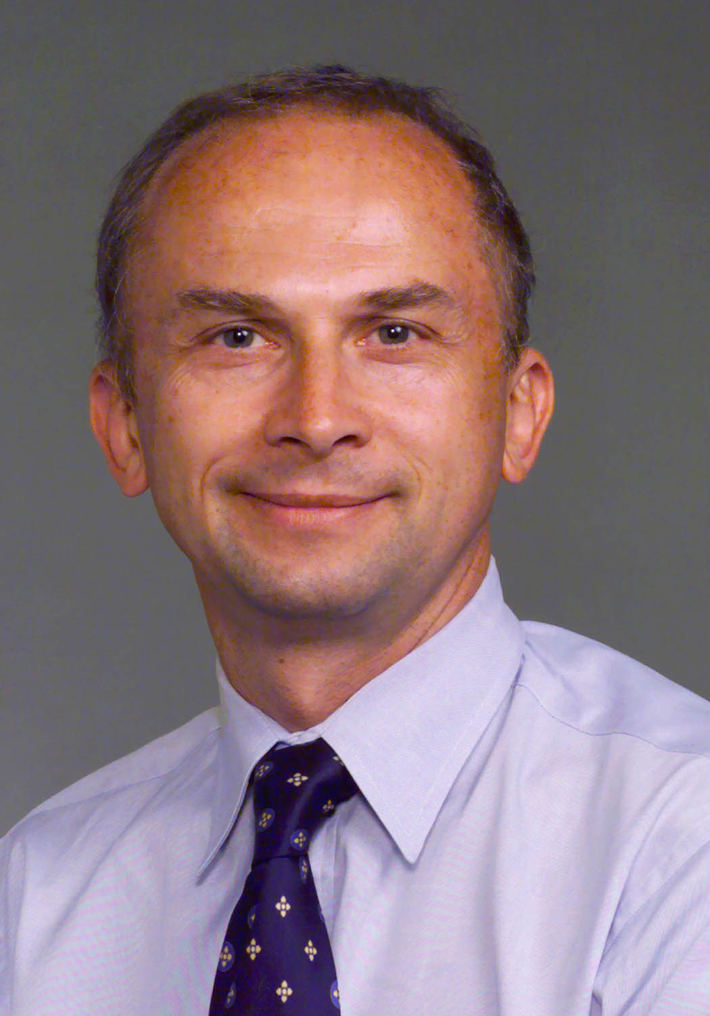
Marco Pahor, M.D.

Professor and Department Chair

Dr. Pahor, an international expert on aging, has been named to lead UF efforts to improve the health of older Americans. Pahor is chairman of the new Department of Aging and Geriatric Research in the College of Medicine and serves as director of the UF Institute on Aging. The new department, the first in the country to focus primarily on aging-related research, will concentrate on finding ways to prevent disabilities in an aging population.

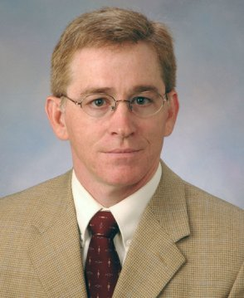
Patrick J. Antonelli, M.D.
Professor and Department Chair

Dr. Antonelli has been named chair of the College of Medicine’s Department of Otolaryngology following a national search. Antonelli has been at UF 10 years, serving as vice chairman of the department since 2001. He is also assistant dean for clinical informatics of the college and chief medical information officer at Shands HealthCare. Dr. Antonelli maintains an active laboratory research program with a focus on the mechanisms of sensorineural hearing loss secondary to middle ear inflammation and injury.

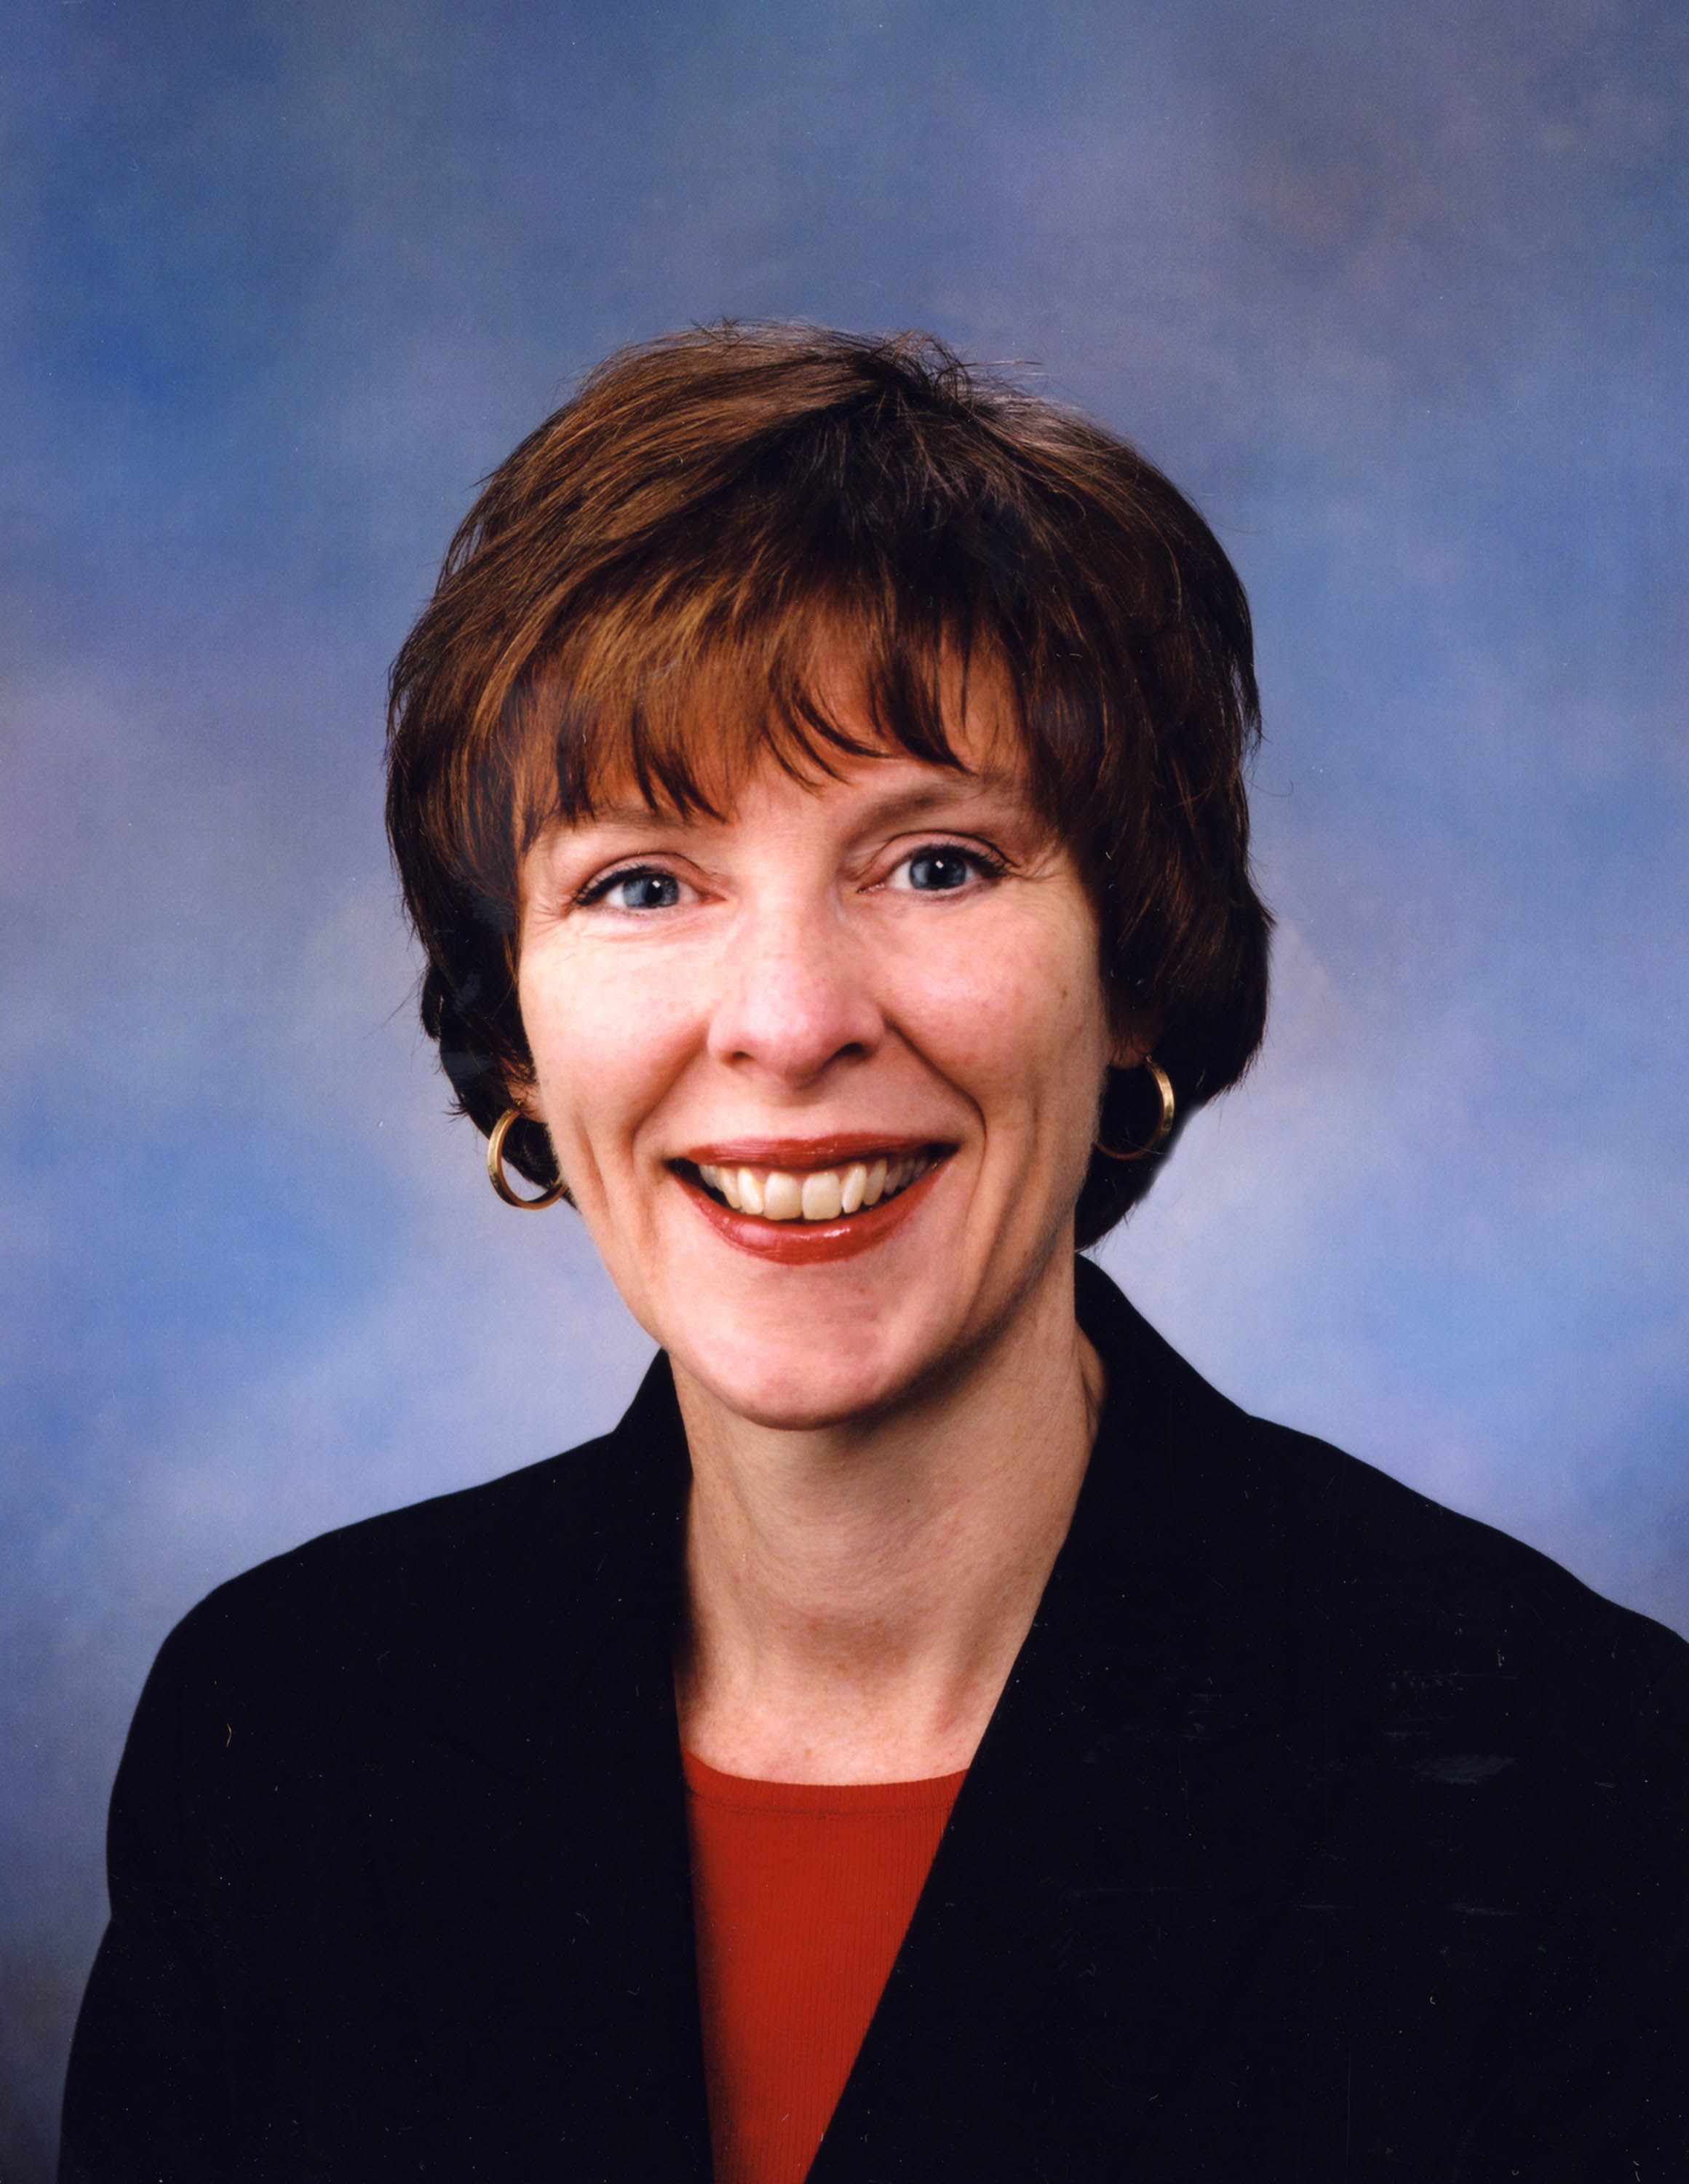
Elizabeth A. Shenkman, Ph.D.

Professor and Department Chair

Dr. Shenkman has been named chair of the Department of Epidemiology and Health Policy Research, a position she has held for the past year on an interim basis. Dr. Shenkman holds a dual faculty appointment in the Department of Pediatrics, is also the director of the Institute for Child Health Policy.

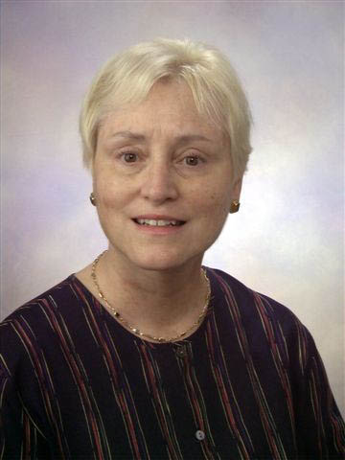
Maureen Goodenow, Ph.D.
Professor

Pediatric HIV/AIDS expert Dr. Goodenow, a UF professor of pathology, immunology and laboratory medicine and pediatrics, has been appointed to a $4 million endowed AIDS research “superchair” position named the Stephany W. Holloway University Chair in AIDS Research. Orlando native John W. Holloway honored his sister Stephany, who died from complications of AIDS in 1990, with a $1 million gift (which was supplemented with matching funds) to UF’s pathology department to establish the superchair position. Also known as a university chair, a superchair is the most highly funded endowed research position at UF.

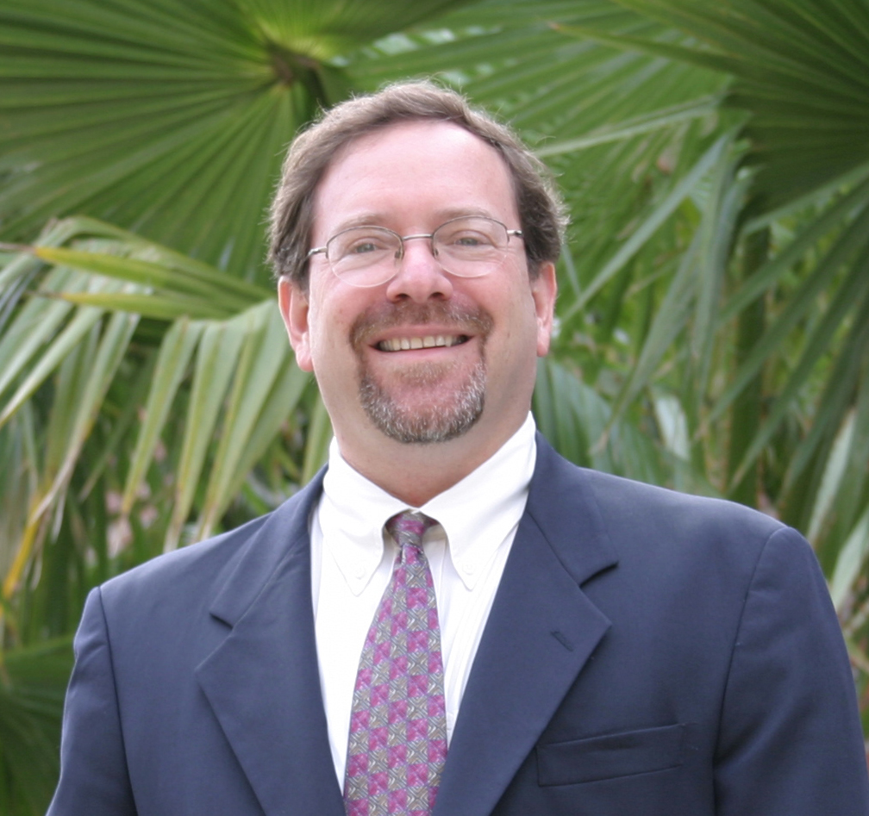
Stuart L. Klein, B.S., M.H.A.

Executive Director

Stuart L. Klein has joined the College of Medicine as executive director of the University of Florida Proton Beam Institute. He is currently working from Gainesville on the operational plans for the multi-million dollar institute set to open in the summer of 2006.

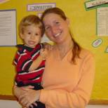
Jennifer Miller, MD

Assistant Professor

Jennifer Miller has been awarded the Pediatric Endocrinology Clinical Scholar Award for the Effects of Growth Hormone on Metabolism and Satiation in Prader-Willi Syndrome. This is a prestigious award given each year to the top young faculty member in the country in the field of Pediatric Endocrinology.

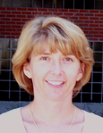
Lucia Notterpek, PhD

Assistant Professor

Lucia Notterpek is the recipient of the 2004 Jordi-Folch-Pi Memorial Award from the American Society for Neurochemistry. This National award is given to an outstanding young investigator who has demonstrated a high level of research competence and has significantly advanced the knowledge of neurochemistry.

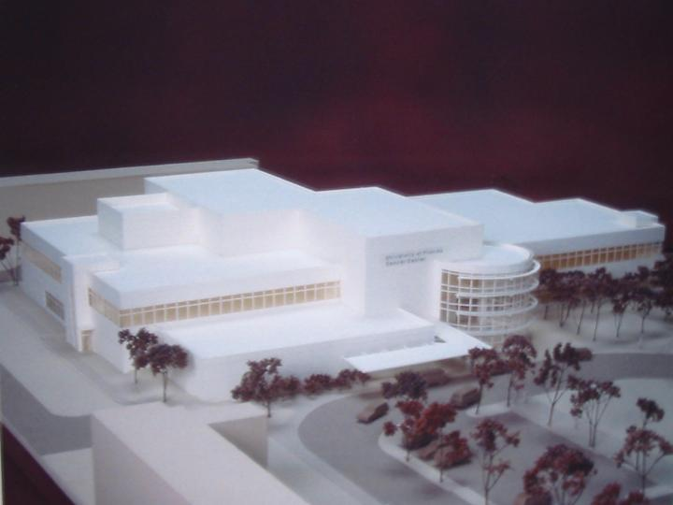
In January of 2003, the University of Florida launched its latest initiative to enhance the care of cancer patients with the groundbreaking of a facility to house Proton Beam Therapy, a more precise form of radiation therapy that promises both significant increases in cancer cure rates as well as significant improvements in the quality of life of cancer survivors. The free-standing, 89,800 square foot facility is located on the campus of the University of Florida at Shands Jacksonville, in Jacksonville, Florida. In addition to providing proton therapy, this facility will include a full range of state-of-the-art conventional radiation therapy options, treatment planning facilities, a clinic, and space for research. When operational in the summer of 2006, the proton facility will join only three currently operational clinical proton therapy facilities in the United States—at Massachusetts General Hospital, Loma Linda University Medical Center and Indiana University.

MARCH 2005
Calendar of Events
Sun | Mon | Tue | Wed | Thur | Fri | Sat
 |  | 1  Spring Break | 2  Spring Break | 3  3:30 – 5:00pm  Council on Planning, Budgeting & Resource Allocation  Room 354 Tigert  Spring Break | 4  Spring Break | 5  Spring Break
6 | 7 | 8  9:30-11:00am  Library Senate Nominating Committee  Room C3-72 Communicore Bldg. | 9  3:00 – 4:30pm  Ad Hoc Committee on Compensation  354 Tigert Hall | 10  (3-5)  Senate Steering Committee  226 Tigert Hall | 11 | 12
13 | 14  9:30-10:30am  Lakes, Vegetation, Landscaping  232 Stadium | 15 | 16 |   17  St. Patrick’s  Day  12:45-1:45pm  Council on Policy Curriculum & Structure  Room 354 Tigert Hall  (3-5)  Faculty Senate Meeting  Reitz Union Auditorium | 18  Library Senate Nominating Committee  11:00am-12:00pm  Keene Faculty Center | 19
20 | 21  Board of Trustees Meeting | 22  Board of Trustees Meeting | 23 | 24  3:30 – 5:00pm  Council on Planning, Budgeting & Resource Allocation  Room 354 Tigert | 25  1:00-2:30pm  Council on Infrastructure & Support  Room 226 Tigert | 26
27  Easter | 28 | 29 | 30 | 31  (3-5)  Senate Steering Committee  226 Tigert Hall

Please contact us if you have any comments, questions, or suggestions.

We welcome your feedback!

